**Burstable Volumes**

* General Purpose SSD under 1 TB size have the ability to burst the IO.  
  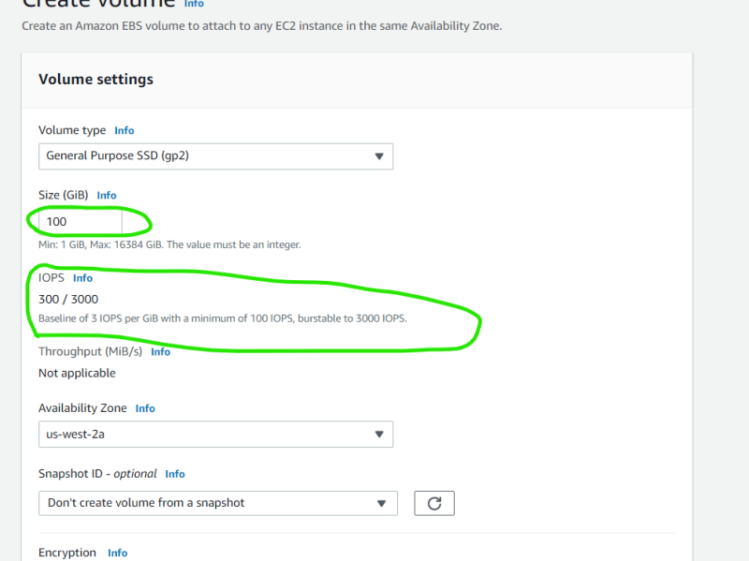
* In the above case we have 3 IOPS per GB so we have 300 IOPS for 100 GB
* When you are not using 300 IOPS, the system accumulates the unused IO and keeps it as IO Credits
* when you are running a peak workload or when there is heavy activity, it will use IO Credits that it has accumulated. The IO can burst up to 3000 IOPS, when all the credits are over, it reverts back to 300 IOPS
* Note: If you donot require more than 3000 IOPS move to GP3 and use the 3000 IOPS as baseline for reduced costs.

**Activity: Create snapshots**

* Create a linux vm and add one extra volume of size 1 GB
* Add some data to it
* Delete the vm
* Create a new linux vm and attach the existing volume, check if you have all the data.
* Delete the vm
* Create the snapshot of the disk with 1 GB and delete volume
* From volume create disk and attach to new linux vm and check the contents
* Copy the snapshot to other region and create a volume from that and attach to a vm
* Now delete the ec2 instace, volume created and snapshot in the secondary region
* Navigate to primary region and delete all the stuff created.